Set A
- a) Create an employee class(id,name,deptname,salary). Define a default and parameterized constructor. Use ‘this’ keyword to initialize instance variables. Keep a count of objects created. Create objects using parameterized constructor and display the object count after each object is created.(Use static member and method). Also display the contents of each object.

- import java.util.*;

- public class employee {
- int id;
- String name;
- String deptname;
- double salary;
- static int cnt = 0;

- employee() {

- }//default counstructor

- void setdata(int id, String name, String deptname, double salary) {
- this.id = id;
- this.name = name;
- this.deptname = deptname;
- this.salary = salary;
- cnt++;
- System.out.println("Count of object : " + cnt);
- }//setdata

- void display() {
- System.out.println(this.id + "\t\t" + this.name + "\t\t" + this.deptname + "\t\t" + this.salary);
- }//displat

- public static void main(String[] args) {
- Scanner sc = new Scanner(System.in);
- System.out.println("Enter number of employee:");
- int n = sc.nextInt();
- employee e[] = new employee[n];

- for (int i = 0; i < n; i++) {
- e[i] = new employee();

- System.out.println("Enter " + (i + 1) + " employee data");

- System.out.println("Enter id:");
- int id = sc.nextInt();
- sc.nextLine();

- System.out.println("Enter Employee Name:");
- String en = sc.nextLine();

- System.out.println("Enter DeptName:");
- String dn = sc.nextLine();

- System.out.println("Enter Salary:");
- double salary = sc.nextDouble();

- e[i].setdata(id, en, dn, salary);
- }//for

- System.out.println("Employee Records Are:");
- System.out.println("Id\tEmployee Name\t\tDept Name\tSalary");
- for (int i = 0; i < n; i++) {
- e[i].display();
- }
- sc.close();
- }//main
- }//class

Output:-
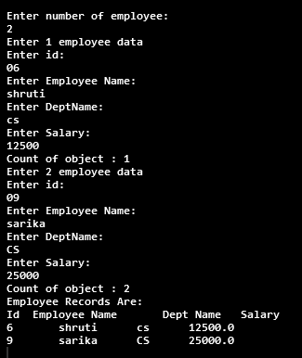

- b) Define Student class(roll_no, name, percentage) to create n objects of the Student class. Accept details from the user for each object. Define a static method “sortStudent” which sorts the array on the basis of percentage.

- import java.util.*;

- public class studentsort {
- int roll_no;
- String name;
- double per;

- studentsort() {

- }// default counstructor

- void setdata(int roll_no, String name, double per) {
- this.roll_no = roll_no;
- this.name = name;
- this.per = per;

- }// setdata

- void display() {
- System.out.println(this.roll_no + "\t\t" + this.name + "\t\t" + this.per);
- }// display

- static void sort(studentsort a[], int n) {
- studentsort temp = new studentsort();
- for (int i = 0; i < n - 1; i++) {
- for (int j = i + 1; j < n; j++) {
- if (a[i].per > a[j].per) {
- temp = a[i];
- a[i] = a[j];
- a[j] = temp;

- }
- }
- }
- }

- public static void main(String[] args) {
- Scanner sc = new Scanner(System.in);
- System.out.println("Enter number of student:");
- int n = sc.nextInt();
- studentsort s[] = new studentsort[n];

- for (int i = 0; i < n; i++) {
- s[i] = new studentsort();

- System.out.println("Enter " + (i + 1) + " student data");

- System.out.println("Enter Roll no:");
- int rn = sc.nextInt();
- sc.nextLine();

- System.out.println("Enter Student Name:");
- String name = sc.nextLine();

- System.out.println("Enter Percentage:");
- double per = sc.nextDouble();

- s[i].setdata(rn, name, per);
- } // for

- System.out.println("\nStudent Records Are:\n");
- System.out.println("R.No\t\tStud Name\tPercentage");
- for (int i = 0; i < n; i++) {
- s[i].display();
- }

- studentsort.sort(s, n);
- System.out.println("\nSorted Student Details:\n");
- System.out.println("R.No\t\tStud Name\tPercentage");
- for (int i = 0; i < n; i++) {
- s[i].display();
- }
- sc.close();
- }// main
- }// class

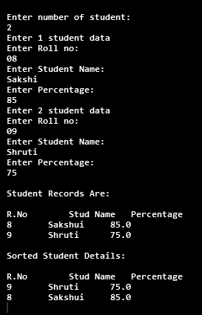
Output:-

c) Write a java program to accept 5 numbers using command line arguments sort and display them.

  - d) Write a java program that take input as a person name in the format of first, middle and last name and then print it in the form last, first and middle name, where in the middle name first character is capital letter.

import java.util.*;
public class DisplayName {
public static void main(String[] args) {
Scanner sc = new Scanner(System.in);
System.out.println("Enter first name:");
String fname = sc.nextLine();
System.out.println("Enter middle name:");
String mname = sc.nextLine();
System.out.println("Enter last name:");
String lname = sc.nextLine();
System.out.println("\nFull Name: " + fname + " " + mname + " " + lname + " ");
String finalname = lname;
finalname = finalname.concat(" ");
String ab = mname.substring(0, 1).toUpperCase();
finalname = finalname.concat(fname);
String cd = mname.substring(1, mname.length());
finalname = finalname.concat(" ");
finalname = finalname.concat(ab);
finalname = finalname.concat(cd);
System.out.println("\n--------Updated Name---------\n");
System.out.println(finalname);
System.out.println();
sc.close();
}
}

Output:-
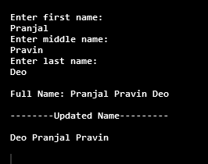

Set B
a) Write a Java program to create a Package “SY” which has a class SYMarks (members – ComputerTotal, MathsTotal, and ElectronicsTotal). Create another package TY which has a class TYMarks (members – Theory, Practicals). Create n objects of Student class (having rollNumber, name, SYMarks and TYMarks). Add the marks of SY and TY computer subjects and calculate the Grade (‘A’ for >= 70, ‘B’ for >= 60 ‘C’ for >= 50 , Pass Class for > =40 else ‘FAIL’) and display the result of the student in proper format.

package SY;

public class SYMarks {
public int ComputerTotal;
public int MathsTotal;
public int ElectronicsTotal;

public SYMarks(int c, int m, int e) {
ComputerTotal = c;
MathsTotal = m;
ElectronicsTotal = e;

}

public String toString() {
return (ComputerTotal + "\t\t" + MathsTotal + "\t\t" + ElectronicsTotal);
}

}
----------------------------------------------------------------------------------------------

package TY;

public class TYMarks {

public int Theory;
public int Practicals;

public TYMarks(int t, int p) {
Theory = t;
Practicals = p;
}

public String toString() {
return Theory + "\t\t" + Practicals;
}

}

----------------------------------------------------------------------------------------------

Student class(main)
import java.util.Scanner;
import SY.SYMarks;
import TY.TYMarks;
public class Student {
int rollno;
String studentname, grade;
SYMarks sym;
TYMarks tym;
Student(int r, String name, SYMarks s, TYMarks t) {
rollno = r;
studentname = name;
sym = s;
tym = t;
}
public String toString() {
return rollno + "\t" + studentname + "\t" + sym + "\t\t" + tym + "\t";
}
void calculategrade() {
int total = sym.ComputerTotal + tym.Theory + tym.Practicals;
double per = total / 14;
if (per >= 70) {
System.out.println("\tA");
} else if (per >= 60) {
System.out.println("\tB");
} else if (per >= 50) {
System.out.println("\tC");
} else if (per >= 40) {
System.out.println("\tPass");
} else {
System.out.println("\tFAIL.!");
}
}
public static void main(String[] args) {
Scanner sc = new Scanner(System.in);
System.out.println("How Many Students:");
int n = sc.nextInt();
Student[] stud = new Student[n];
for (int i = 0; i < n; i++) {
System.out.println("Enter " + (i + 1) + " student data");
System.out.println("Enter Roll no:");
int roll_no = sc.nextInt();
sc.nextLine();
System.out.println("Enter Student Name:");
String name = sc.nextLine();
System.out.println("Enter SY Percentage(Comp total,Math total,Elect total):");
int ct = sc.nextInt();
int mt = sc.nextInt();
int et = sc.nextInt();
SYMarks sym = new SYMarks(ct, mt, et);
System.out.println("Enter TY Marks (Theory and Practicals)");
int th = sc.nextInt();
int pr = sc.nextInt();
TYMarks tym = new TYMarks(th, pr);
stud[i] = new Student(roll_no, name, sym, tym);
}
System.out.println("\n* STUDENT DETAILS *"); System.out.println("R.No\tName\tCompTotal\tMathTotal\tElectTotal\tTheory\t\tPractical\tGrade");
for (int i = 0; i < n; i++) {
System.out.print(stud[i]);
stud[i].calculategrade();
}
sc.close();
}
}
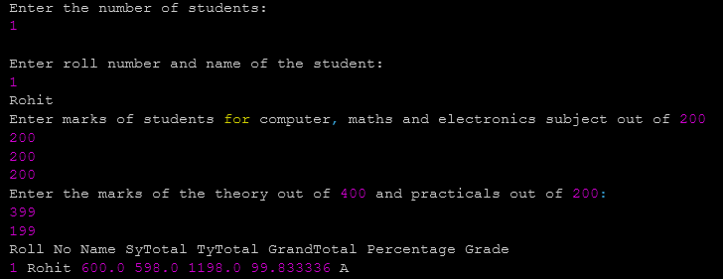
Output:-

- b) Define a class CricketPlayer (name,no_of_innings,no_of_times_notout, totatruns, bat_avg). Create an array of n player objects .Calculate the batting average for each player using static method avg(). Define a static sort method which sorts the array on the basis of average. Display the player details in sorted order.

- import java.util.*;

- public class CricketPlayer {
- String name;
- int no_of_innings;
- int no_of_times_notout;
- double totatruns;
- double bat_avg;

- void setdata(String pn, int ni, int no, Double tr) {
- name = pn;
- no_of_innings = ni;
- no_of_times_notout = no;
- totatruns = tr;
- }

- static void avg(CricketPlayer a[], int n) {
- for (int i = 0; i < n; i++) {
- a[i].bat_avg = (a[i].totatruns / (a[i].no_of_innings - a[i].no_of_times_notout));
- }
- }

- void display() {
- System.out.println(name + "\t\t\t" + no_of_innings + "\t\t" + no_of_times_notout + "\t\t"
- + totatruns + "\t\t" + bat_avg);
- }
- static void sort(CricketPlayer a[], int n) {
- CricketPlayer temp = new CricketPlayer();
- for (int i = 0; i < n - 1; i++) {
- for (int j = i + 1; j < n; j++) {
- if (a[i].bat_avg < a[j].bat_avg) {
- temp = a[i];
- a[i] = a[j];
- a[j] = temp;
- }
- }
- }
- }
- public static void main(String[] args) {
- Scanner sc = new Scanner(System.in);
- System.out.println("Enter no of Player:");
- int n = sc.nextInt();
- CricketPlayer cp[] = new CricketPlayer[n];
- for (int i = 0; i < n; i++) {
- cp[i] = new CricketPlayer();
- System.out.println("Enter " + (i + 1) + " Player data");
- System.out.println("Enter Player Name : ");
- sc.nextLine();
- String pn = sc.nextLine();
- System.out.println("Enter no of Innings:");
- int ni = sc.nextInt();
- System.out.println("Enter no of times NotOut :");
- int no = sc.nextInt();
- System.out.println("Enter Total Runs :");
- Double tr = sc.nextDouble();
- cp[i].setdata(pn, ni, no, tr);
- }
- System.out.println("\n\t\t\t\t**Player Records**\n");
- System.out.println("Player Name \tNo_Of_Innings \tNo_Of_Times_NotOut \tTotal Runs \tBat Avg");

- CricketPlayer.avg(cp, n);
- for (int i = 0; i < n; i++) {
- cp[i].display();
- }
- System.out.println("\n\t\t\t\t**Sorted Player Records**\n");
- CricketPlayer.sort(cp, n);
- System.out.println("Player Name \tNo_Of_Innings \tNo_Of_Times_NotOut \tTotal Runs \tBat Avg");
- for (int i = 0; i < n; i++) {
- cp[i].display();
- }
- sc.close();
- }
- }
- output:-

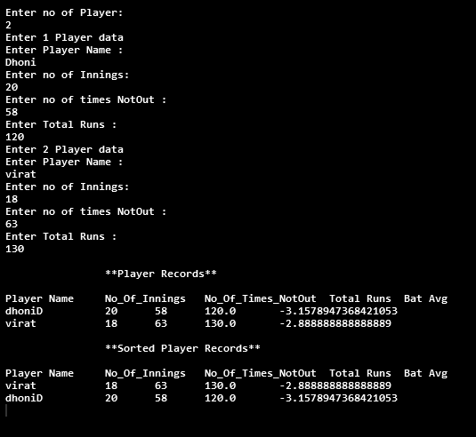

- Set C
- a) Write a package for String operation which has two classes Con and Comp. Con class has to concatenates two strings and comp class compares two strings. Also display proper message on execution.

- package ConComp;

- public class comp1 {

- public void displaycomp(String s1, String s2){

- System.out.println("Compared String : " +s1.compareTo(s2));
- }
- }
- ---------------------------------------------------------------------------------------------------------------------

package ConComp;

import java.io.ObjectInputFilter.Config;
import java.util.Scanner;
import ConComp.*;

public class Demo {
public static void main(String[] args) {
Scanner sc = new Scanner(System.in);

System.out.println("Enter 1St String : ");
String s1 = sc.nextLine();

System.out.println("Enter 2nd String : ");
String s2 = sc.nextLine();
comp1 c = new comp1();
c.displaycomp(s1,s2);
comp1 cm = new comp1();
cm.displaycomp(s1,s2);
sc.close();
}
}

Output:-

